DAY 22 REPORT (HOME TASK)
TASK NAME - E-Commerce Sales Analysis with Data Transformation in Power BI
1. Objective
The objective of this project is to analyze online shopping sales data using Power BI and create an interactive dashboard to understand customer behavior, product performance, payment trends, and delivery status.

2. Dataset Description
The dataset represents an online shopping system with the following fields:
- Order_ID
- Customer_Name
- Gender
- City
- Product_Category
- Product_Name
- Order_Date
- Payment_Method
- Quantity
- Unit_Price
- Total_Amount
- Delivery_Status
This dataset was enhanced using calculated columns for better business analysis.

3. Data Transformation:
The dataset was improved using conditional logic in Power BI.
1.Profit Category
- LOW → < 2000
- MEDIUM → 2000 to 10000
- HIGH → > 10000
Used to classify sales value.
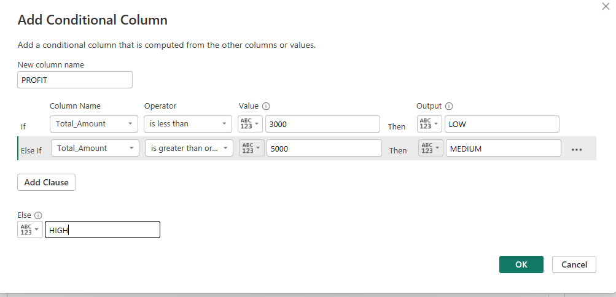

2. Order Priority
- High Priority
- Moderate Priority
- Low Priority
Helps identify urgency of orders.
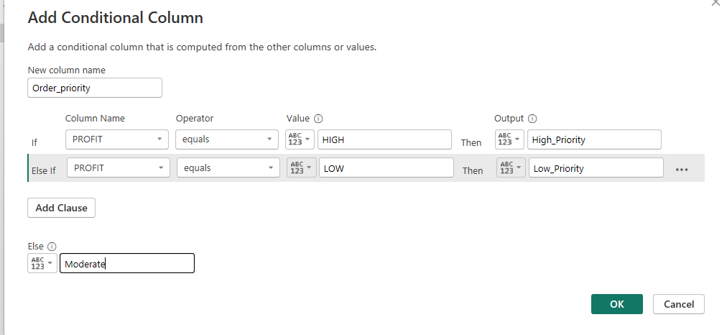

3. Customer Segment
- Low Spender → < 2000
- Medium Spender → 2000–10000
- High Spender → > 10000
Used to analyze customer buying behavior.
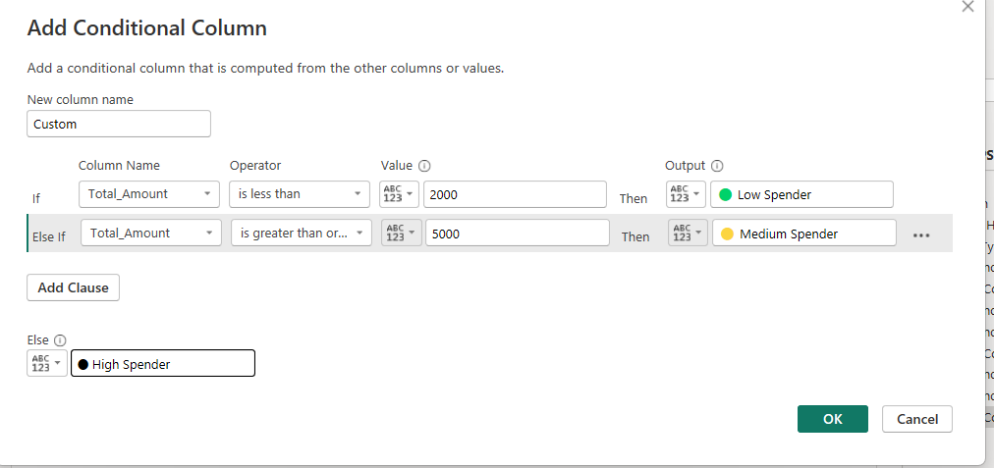
AFTER TRANSFORMATION:
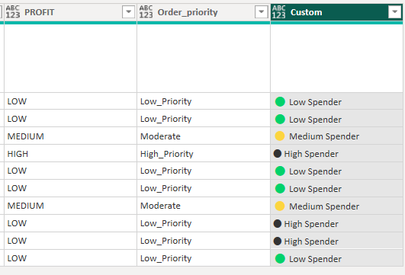
Dashboard Chart :
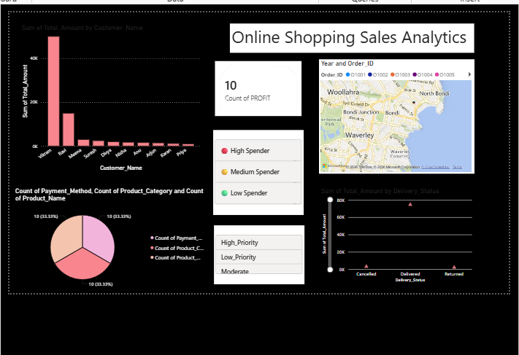
1.Bar Chart – Sum of Total Amount by Customer Name:
This chart shows the total spending of each customer.
It helps to identify:
- Top spending customers
- Medium spending customers
- Low spending customers
Business Use:
Used to find high-value customers who contribute more to sales.

2.Pie Chart – Count of Payment Method / Product Category / Product Name
This chart shows the distribution of different categories in the dataset.
It helps to understand:
- Which payment method is most used (UPI / Card / COD)
- Which product category is most sold
- Product popularity distribution
Business Use:
Used for sales distribution analysis and customer preference study.

3.Card Visual – Count of PROFIT
This shows the total number of profit categories (LOW / MEDIUM / HIGH).
It helps to:
- Summarize profit classification in dataset
- Understand business performance level
Business Use:
Quick overview of overall profit structure.

4.Map Visual – Year and Order_ID (Location Analysis)
This map shows order distribution based on location data.
It helps to:
- Identify where orders are coming from
- Understand geographical sales pattern
Business Use:
Used for location-based sales tracking.

5.Bar Chart – Sum of Total Amount by Delivery Status
This chart shows sales based on delivery outcome.
Categories:
- Delivered
- Cancelled
- Returned
It helps to measure:
- Delivery success rate
- Failed orders
- Return cases

7. Conclusion
The Online Shopping Sales Dashboard successfully analyzes sales performance, customer behavior, and delivery efficiency. It helps in making data-driven business decisions using interactive visualizations.

